*The TurriTellaGram 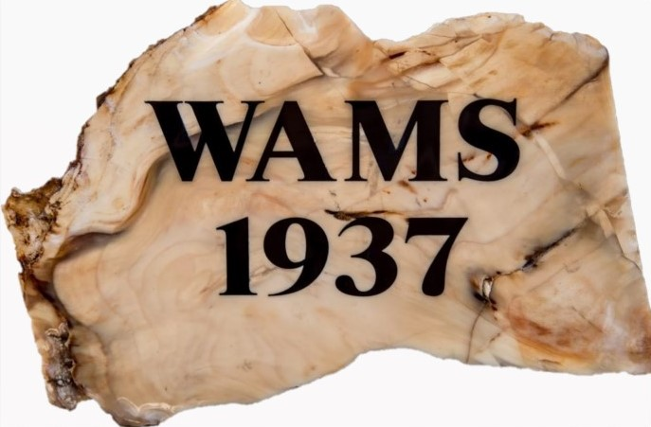 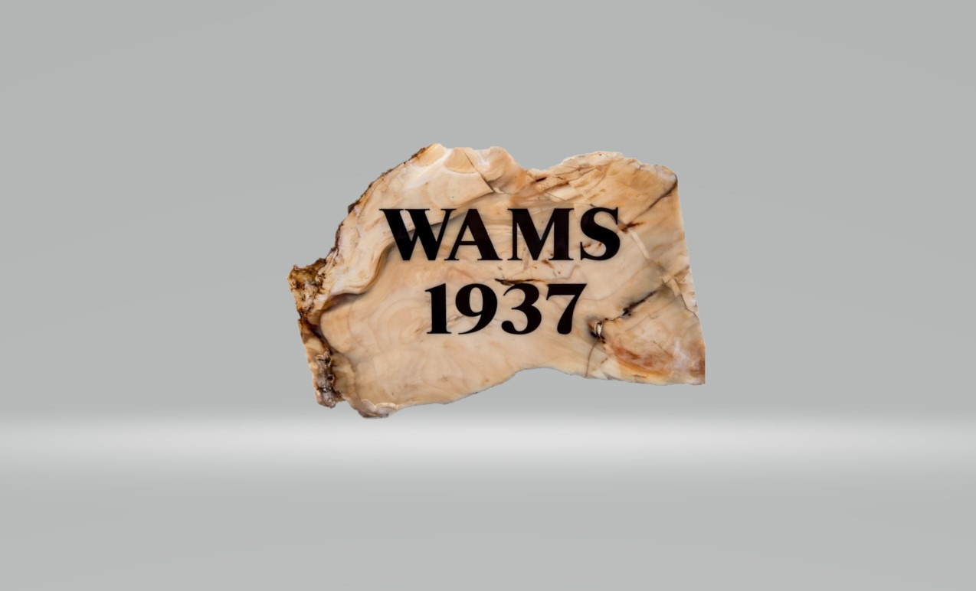

Washington Agate and Mineral Society is an educational & social non-profit organization
dedicated to promoting the interest in mineralogy, geological sciences and lapidary arts and to foster
good fellowship and recreation.

WAMS (The Oldest Rock and Mineral Club in Washington State, Founded February 3, 1937)

Mailing address: WAMS Olympia, PO Box 2553 Olympia, WA 98507-2553
Email address: wamsolympia@gmail.com
Website: https://wamsolympia.com
Facebook: Washington agate and mineral society
Instagram: wamsolympia
WAMS is a non profit 501(c)(3) organization

Officers: Committee Chairs:
PRESIDENT: Jim Sachet PROGRAMS: Jim Sachet
VICE-PRESIDENT: Tom Prang SHOW CHAIRMAN: Dan DeBoer
SECRETARY: Doug Shank WEBMASTER:
TREASURER: Doug S. FIELD TRIP COORD. Sandy Skill
NEWSLETTER: Doug S.

Next Meeting: Tuesday February 6, 2024 6:30 PM.

WAMS Olympia meets the first Tuesday of each month, 6:30 p.m., at the First Baptist Church of Lacey, 4702 22nd (corner of College St. and 22nd) MAP

Membership for one year is $15.00 for one person and $25.00 for a family. membership application form

If you have any articles, photos, or comments for the newsletter, please email your to me at wamsolympia@gmail.com

*Newsletter title is tentative pending a vote.

DONATIONS:

We appreciate many types of donations to our non-profit organization: rocks, fossils, mineral collections and equipment. We will also accept monetary donations. If you have questions or would like to schedule a drop off contact us at, wamsolympia@gmail.com
The refreshments for this month’s meeting will be provided by:

February: Jerry
March: Gretchen

What is the meaning of this?

Basalt (part 2)

Article accessed 12/27/2023 from: https://geologyscience.com/rocks/basalt/

- Composition-based Classification:
  - Tholeiitic Basalt: This type of basalt is characterized by its low silica content (typically around 45-52 wt%) and relatively high iron and magnesium content. Tholeiitic basalt is typically associated with mid-oceanic ridges and oceanic islands, and it is the most common type of basalt found on Earth.
  - Alkali Basalt: This type of basalt has higher silica content (typically around 48-52 wt%) and higher alkali elements (sodium and potassium) compared to tholeiitic basalt. Alkali basalt is typically associated with volcanic arcs, rift zones, and intraplate settings.
- Texture-based Classification:
  - Aphanitic Basalt: This type of basalt has a fine-grained texture, where individual minerals are not visible with the naked eye. It typically forms when magma cools rapidly at the Earth’s surface, such as in volcanic eruptions or when magma intrudes into shallow crustal rocks.
  - Porphyritic Basalt: This type of basalt has a combination of fine-grained matrix (groundmass) and larger visible crystals (phenocrysts) embedded within it. Porphyritic basalt typically forms when magma undergoes two stages of cooling, with slower cooling allowing for the formation of larger crystals.
- Formation Environment-based Classification:
  - Oceanic Basalt: This type of basalt forms in oceanic settings, such as mid-oceanic ridges, oceanic islands, and seafloor spreading centers. Oceanic basalt is typically tholeiitic in composition and is characterized by a fine-grained texture.
  - Continental Basalt: This type of basalt forms in continental settings, such as rift zones, flood basalt provinces, and volcanic plateaus. Continental basalt can be either tholeiitic or alkali basalt in composition and can exhibit a variety of textures ranging from aphanitic to porphyritic.
- Other Classification:
  - Pillow Basalt: This type of basalt forms underwater, typically in submarine volcanic eruptions or at the base of lava flows in submarine environments. Pillow basalt is characterized by its rounded, pillow-like structures formed by the rapid quenching of lava in water.
  - Columnar Basalt: This type of basalt exhibits a unique columnar jointing pattern, where the lava flow or dike fractures into hexagonal or polygonal columns as it cools and contracts. Columnar basalt is often found in volcanic regions and is known for its distinct and striking appearance.
These are some of the common classifications of basalt based on composition, texture, and formation
environment. Basaltic rocks can exhibit a wide range of variations and characteristics, making them an
interesting and diverse group of igneous rocks in geology.
Basalt has a strict chemical definition. It is defined in the TAS diagram shown above. Basalt is an
igneous rock that contains more than 45 and less than 52% of SiO2 and less than five percent of total
alkalies (K2O + Na2O)3.
Types of Basalt
Basalt is a volcanic rock that can exhibit different types or varieties based on various factors such as
composition, texture, and mineralogy. Some of the commonly recognized types of basalt include:
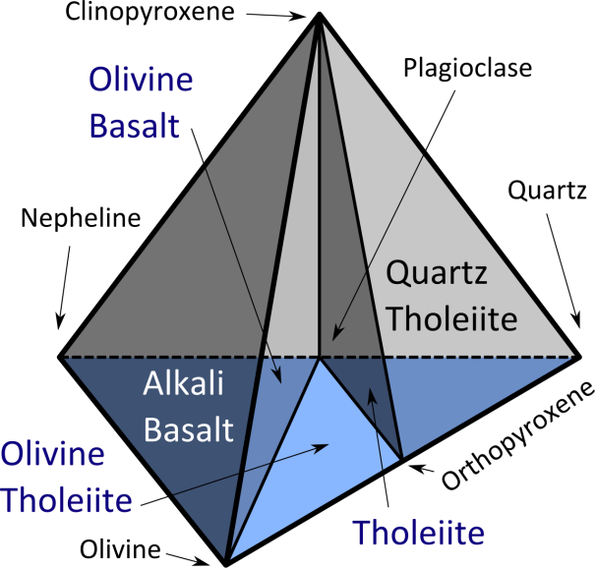
Basalt types: tholeiites vs alkali basalts
Tholeiitic basalt is relatively rich in silica and poor in sodium. Included in this category are most basalts of the ocean floor, most large oceanic islands, and continental flood basalts such as the Columbia River Plateau.
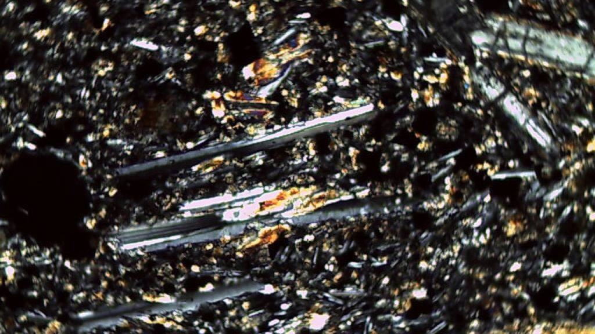

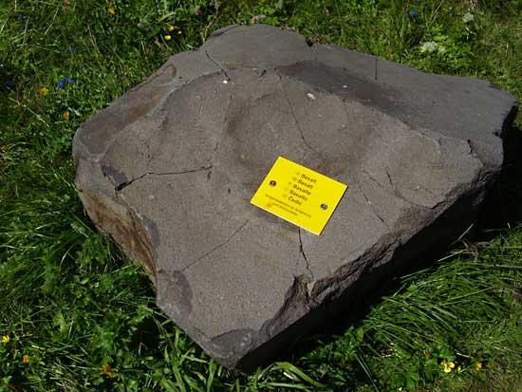
Tholeiitic basalt
High and low titanium basalts. Basalt rocks are in some cases classified after their titanium (Ti) content in High-Ti and Low-Ti varieties. High-Ti and Low-Ti basalts have been distinguished in the Paraná and Etendeka traps and the Emeishan Traps.
Mid-ocean ridge basalt (MORB) is a tholeiitic basalt commonly erupted only at ocean ridges and is characteristically low in incompatible elements
High-alumina basalt may be silica-undersaturated or -oversaturated (see normative mineralogy). It has greater than 17% alumina (Al₂O₃) and is intermediate in composition between tholeiitic basalt and alkali basalt; the relatively alumina-rich composition is based on rocks without phenocrysts of plagioclase.
Alkali basalt is relatively poor in silica and rich in sodium. It is silica-undersaturated and may contain feldspathoids, alkali feldspar and phlogopite.
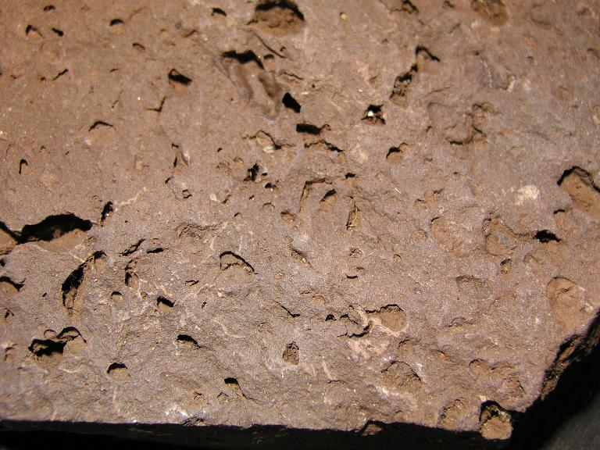
Alkaline Basalt
Boninite is a high-magnesium form of basalt that is erupted generally in back-arc basins, distinguished by its low titanium content and trace-element composition.
Texture and structure of basalt
The texture and structure of basalt are important characteristics that provide insights into the rock’s formation and cooling history. Here are some commonly observed textures and structures in basalt:
- Aphanitic Texture: Aphanitic texture is a fine-grained texture that is commonly observed in basalt. It is characterized by small mineral grains that are not easily visible to the naked eye. Aphanitic basalt typically forms from relatively rapid cooling of lava flows, either on the Earth’s surface or as thin intrusions, which prevents the formation of large mineral crystals.
- Vesicular Texture: Vesicular texture is characterized by the presence of vesicles, which are small cavities or gas bubbles, in the basaltic rock. Vesicles form when gas is trapped in the magma during volcanic eruptions and then solidifies as the lava cools and solidifies. Vesicular basalt often has a porous and lightweight appearance due to the presence of these vesicles, and the vesicles can vary in size and shape.
- Glassy Texture: Glassy texture is characterized by a non-crystalline, glass-like appearance in basaltic rocks. Glassy basalt typically forms when lava cools very rapidly, preventing the formation of mineral crystals. It is usually black or dark in color and has a smooth, glassy surface.
- Columnar Jointing: Columnar jointing is a characteristic structure that can be observed in some basaltic rocks, particularly in thick lava flows. It forms when the lava cools and contracts, resulting in the formation of vertical or near-vertical columns with hexagonal or polygonal shapes. Columnar jointing is often seen in exposed basaltic outcrops and can create unique and striking geological formations.
- Amygdaloidal Texture: Amygdaloidal texture is characterized by the presence of amygdales, which are rounded or elongated cavities in the basaltic rock that are filled with secondary minerals. Amygdales form when gas bubbles in the lava are filled with mineral-rich fluids after the lava has solidified. Amygdaloidal basalt often displays a speckled appearance due to the contrasting colors of the secondary minerals filling the amygdales.
- Porphyritic Texture: Porphyritic texture is characterized by the presence of larger mineral crystals,
known as phenocrysts, embedded in a finer-grained matrix. Porphyritic basalt typically forms when the lava cools at different rates, allowing for the growth of larger crystals in a slower-cooling environment before the lava erupts onto the surface. These are some of the common textures and structures that can be observed in basaltic rocks. The texture and structure of basalt provide important information about the cooling rate, eruption environment, and cooling history of the rock, which can shed light on the volcanic processes and geologic history of an area.
Geochemistry of Basalt
The geochemistry of basalt refers to the composition and distribution of chemical elements and minerals in basaltic rocks. Basalt is typically composed of dark-colored minerals such as pyroxene, olivine, and plagioclase feldspar, along with small amounts of other minerals such as magnetite, ilmenite, and apatite. The chemical composition of basalt can vary depending on the source magma, eruption environment, and subsequent weathering and alteration processes. Here are some key aspects of the geochemistry of basalt:
- Major Elements: Basalt is typically rich in silica (SiO2) and contains varying amounts of other major elements such as aluminum (Al), iron (Fe), calcium (Ca), magnesium (Mg), sodium (Na), and potassium (K). The proportions of these elements in basalt can vary, leading to different types of basalt with distinct chemical compositions. For example, alkaline basalt is characterized by higher proportions of sodium and potassium, while tholeiitic basalt is characterized by higher proportions of iron and magnesium.
- Trace Elements: Basalt also contains trace elements, which are present in much smaller amounts but can have significant geochemical and geologic implications. These trace elements can be used to study the source magma, melting processes, and tectonic settings of basaltic rocks. For example, the presence of certain trace elements such as chromium (Cr), nickel (Ni), and cobalt (Co) can indicate a mantle source for the basalt, while the presence of elements like zirconium (Zr) and titanium (Ti) can provide insights into the crystallization history of the magma.
- Isotopes: Isotopes are variants of an element that have different numbers of neutrons in their atomic nuclei. Basalt can exhibit isotopic variations in certain elements, such as oxygen (O), strontium (Sr), and neodymium (Nd), which can provide information about the origin and evolution of the magma source, as well as the processes of magma generation and differentiation. Isotopic studies of basalt can help determine the age of the rock, the isotopic composition of the source mantle, and the degree of mantle melting and crustal contamination.
- Weathering and Alteration: Basalt can undergo weathering and alteration processes after its formation, which can result in changes to its chemical composition. For example, basalt can weather to form clay minerals, and alteration processes can lead to the formation of secondary minerals such as zeolites, chlorites, and carbonates. These weathering and alteration processes can affect the geochemical characteristics of basalt and provide information about the geologic history and environmental conditions of the area.
The geochemistry of basalt plays a crucial role in understanding the origin, evolution, and geologic significance of basaltic rocks. Geochemical studies of basalt can provide insights into the magma source, melting processes, tectonic settings, and environmental conditions during and after basalt formation, helping scientists unravel the complex geological history of the Earth.
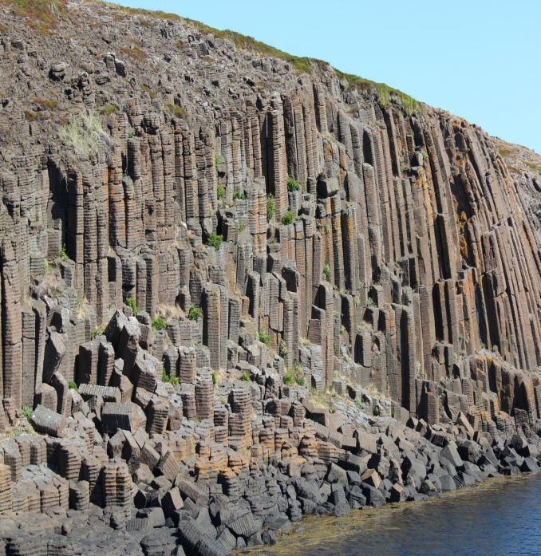
Columnar Basalt

Petrogenesis of Basalt
The petrogenesis of basalt involves the processes by which basaltic rocks are formed and their origin. Basaltic rocks can be generated through various mechanisms, including partial melting of the mantle, melting of the lower crust, and fractional crystallization of magma. Here are some key petrogenetic processes involved in the formation of basalt:
- Partial Melting of the Mantle: Basalt is often derived from partial melting of the Earth’s mantle, which is the solid layer beneath the Earth’s crust. Mantle melting can occur due to processes such as decompression melting, which happens when mantle rocks rise to shallower depths and the decrease in pressure lowers the melting point of the rock. This can occur at divergent plate boundaries where tectonic plates move apart, allowing mantle material to upwell and melt to form basaltic magma.
- Melting of the Lower Crust: Another process that can generate basalt is the melting of the lower crust. This can occur in areas where the crust is thick, such as during the formation of large volcanic mountain ranges, where the lower crust can undergo partial melting due to the high heat and pressure. This melted lower crust can then rise to the surface and erupt as basaltic magma.
- Fractional Crystallization: Basaltic magma can undergo fractional crystallization, which is the process where minerals crystallize and separate from the melt as it cools. The first minerals to crystallize from the magma are typically calcium-rich plagioclase feldspar and pyroxene, which are denser and settle to the bottom of the magma chamber, leaving behind a more silica-rich melt. This silica-rich melt can then erupt at the surface as basaltic magma, which may have a different composition compared to the original magma due to the removal of certain minerals during fractional crystallization.
- Assimilation and Magma Mixing: Basaltic magmas can also undergo assimilation and magma mixing, which occurs when the magma interacts with and incorporates surrounding rocks. For example, during the ascent of basaltic magma towards the Earth’s surface, it can assimilate and melt surrounding rocks, such as crustal rocks or older basaltic rocks, which can affect the composition of the magma. Magma mixing can also occur when two or more magmas with different compositions come into contact and mix, leading to a hybrid magma with intermediate characteristics.
- Mantle Heterogeneity: The mantle beneath the Earth’s crust is not uniformly homogeneous and can contain various compositional heterogeneities, such as mantle plumes, subducted oceanic crust, and recycled oceanic lithosphere. These mantle heterogeneities can influence the composition and characteristics of basaltic magmas that are derived from mantle melting, resulting in variations in basaltic rocks around the world.
The petrogenesis of basalt is a complex process that involves multiple mechanisms, including partial melting of the mantle, melting of the lower crust, fractional crystallization, assimilation and magma mixing, and the influence of mantle heterogeneities. The study of petrogenesis provides insights into the origin and evolution of basaltic rocks, helping scientists understand the geologic processes that shape the Earth’s crust and mantle.
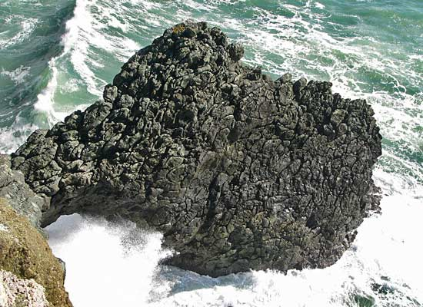
Pillow basalt at Point Bonita
Environmental and Economic Significance of Basalt
Basalt has several environmental and economic significances. Here are some of them:
Environmental Significance of Basalt:
- Soil Formation: Basalt weathering and erosion can contribute to soil formation, as it releases essential nutrients such as calcium, magnesium, and potassium into the soil. Basaltic soils are often fertile and can support agricultural activities.
- Carbon Sequestration: Basalt has the potential for carbon sequestration, as it reacts with carbon dioxide (CO2) from the atmosphere to form stable carbonate minerals through a process called mineral carbonation. This can help mitigate climate change by storing CO2 in a solid form and reducing its release into the atmosphere.
- Natural Habitat: Basaltic landscapes can provide habitats for various plant and animal species, including unique flora and fauna that have adapted to the harsh conditions of basaltic terrains. These habitats can have ecological and conservation significance.
Economic Significance of Basalt:
- Construction Material: Basalt is widely used as a construction material due to its durability, hardness, and resistance to weathering. It is used as crushed stone for road construction, railroad ballast, concrete aggregates, and building stones. Basalt fibers, which are derived from basalt rocks, are also used as reinforcement in construction materials.
- Industrial Uses: Basalt can be used in various industrial applications, such as in the manufacturing of basalt fiber, which has excellent mechanical properties and is used in composites, textiles, and other high-performance applications. Basalt is also used as a raw material for the production of basaltic rock wool, a type of insulation material.
- Tourism and Recreation: Basaltic landscapes, such as basalt columns and lava flows, can be attractive for tourism and recreation purposes. Many famous landmarks, such as the Giant’s Causeway in Northern Ireland and the Devil’s Tower in the United States, are made of basalt and attract tourists from around the world.
- Geothermal Energy: Basaltic formations can serve as reservoirs for geothermal energy production. Hot water or steam can be extracted from underground basaltic rocks to generate electricity, providing a renewable and clean energy source.
In summary, basalt has both environmental and economic significance, ranging from its role in soil formation, carbon sequestration, and natural habitats to its uses as construction materials, industrial applications, tourism and recreation, and geothermal energy production.
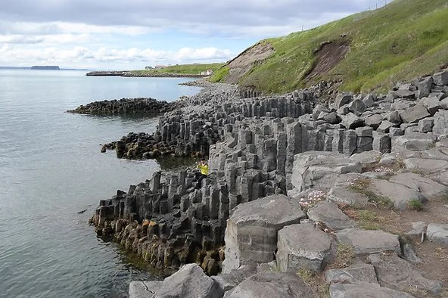
Staðarbjörg small basalt column cliffs

FIELD TRIPS:

Washington State Mineral Council (WSMC) Fieldtrips:
WAMS members are permitted to join WSMC on their field trips.

- 02/17/24, Western Washington University (Bellingham) Earth Science lab: TRIP INFO LINK

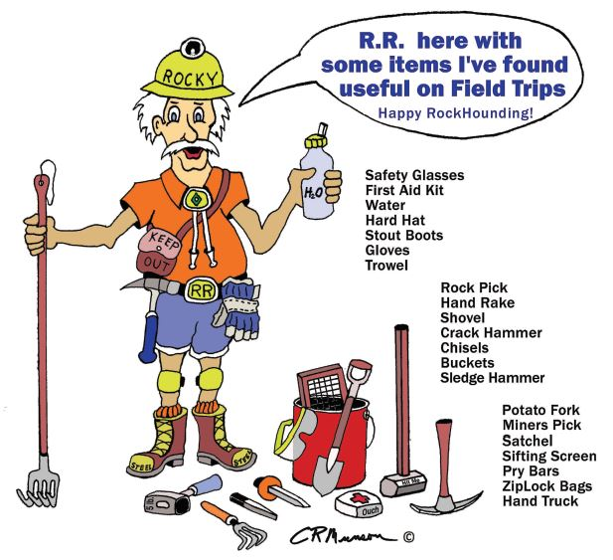

The Rockhound’s Code of Ethics
I will respect both private and public property and will do no collecting on privately owned land without permission from the owner.
I will keep informed on all laws, regulations and rules governing collecting on private lands and will observe them.
I will to the best of my ability, ascertain the boundary lines of property on which I plan to collect.
I will use no firearms or blasting materials in collecting areas.
I will cause no willful damage to property of any kind, such as fences, signs, buildings, etc.
I will leave all gates as found.
I will build fires only in designated or safe places and will be certain they are completely extinguished before leaving the area.
I will discard no burning materials – matches, cigarettes, etc.
I will fill all excavation holes which may be dangerous to livestock.
I will not contaminate wells, creeks, or other water supplies.
I will cause no damage to collecting material and will take home only what I can reasonably use.
I will support the Rockhound Project H.E.L.P. (Help Eliminate Litter Please) and will leave all collecting areas devoid of litter, regardless of how found.
I will cooperate with Field Trip Leaders and those in designated authority in all collecting areas.
I will report to my Club or Federation Officers, Bureau of Land Management, or other proper authorities, any deposit of petrified wood or other material on public lands which should be protected for the enjoyment of future generations and for public educational and scientific purposes.
I will appreciate and protect our heritage of Natural Resources.
I will observe the “Golden Rule”, will use Good Outdoor Manners and will at all time conduct myself in a manner which will add to the stature and Public Image of Rockhounds

Links to other community websites:

https://www.washingtonminerals.com/
http://www.northseattlerockclub.org/
http://orerockon.com/ore_rock.htm
https://mineralcouncil.wordpress.com/
https://puyallupvalleygemandmineralclub.com/
https://www.kmgsrockclub.com/
https://everettrockclub.com/
https://www.marysvillerockclub.com/
https://www.cascademineralogicalsociety.org/
https://www.amfed.org/ American Federation of Mineralogical Societies (links to clubs around the nation)

BLM Resources:

BLM PDF "Can I Keep This" (right click and select open hyperlink- it’s very slow to open)
https://gbp-blm-egis.hub.arcgis.com/ (this app opens with an unsupported browser)

General interest sites:

https://www.gatorgirlrocks.com
BLM PDF Explore Your Public Lands (copy and paste into your internet browser)
https://www.blm.gov/outdoorethics
https://awesomegems.com/
http://dsc.discovery.com

GEM AND MINERAL SHOWS:
Link to gem and mineral shows, shops, and more: https://www.rockandmineralshows.com/
WASHINGTON

Whidbey Island Gem Club Annual Gem Show
February 10th 9am—5pm
February 11th 9am—5pm
Oak Harbor Senior Center 51 SE Jerome St.
Oak Harbor WA

East King Co Club Annual Rock and Gem Show
March 2nd 10am - 6pm
March 3rd 10am - 5pm
Pickering Barn 1730 10th Ave NW
Issaquah, WA

Mt. Baker Rock & Gem Club 62nd Annual Rock and Gem Show
March 23rd 10am - 6pm
March 24th 10am - 5pm
Ferndale Pavilion 2007 Cherry Street
Ferndale, WA

Maplewood Rock & Gem Club - 04/13/2024
Start Date: 04/13/2024
End Date: 04/14/2024
Hours: 10:00 - 5:00
Venue: Maplewood Rock and Gem Clubhouse
Address: 8802 196th St SW
Maplewood Rock and Gem Clubhouse
Edmonds, WA
Website: http://www.maplewoodrockclub.com/home

Lakeside Gem & Mineral Club 27th Annual Rock & Mineral Show
April 2024 20th 10am - 5pm
21st 10am - 4pm
$5 adults, 12 & under free
Benton Franklin CountyFairgrounds Building 2, 1500 S. Oak
Kennewick, WA

Parade of Gems - 04/26/2024
Start Date: 04/26/2024
End Date: 04/28/2024
Hours: Fri 10:00-4:00 Sat 10:00-5:00 Sun 10:00-4:00
Venue: Central Washington State Fair Grounds
Address: 1301 South Fair Avenue
Central Washington State Fair Grounds
Yakima, WA http://www.yakimarockclub.com/
Website: http://www.yakimarockclub.com/
Seattle Mineral Market - 05/18/2024
Start Date: 05/18/2024
End Date: 05/19/2024
Hours: Sat 10:00 - 6:00 Sun 11:00 - 5:00
Venue: Hangar 30 Building @ Magnuson Park
Address: 7400 Sand Point Way NE
Hangar 30 Building @ Magnuson Park
Seattle, WA 98115
Website: https://elementalendeavors.com/seattle-mineral-market

Puyallup Valley Gem and Mineral Club Show - 05/31/2024
Start Date: 05/31/2024
End Date: 06/02/2024
Hours: Fri 12:00-5:00 Sat 10:00-5:00 Sun 10:00-3:00
Venue: Swiss Park
Address: 9205 198th Ave E
Swiss Park
Bonney Lake, WA 98391
Website: https://puyallupvalleygemandmineralclub.com/

Maplewood Rock & Gem Sale - 08/10/2024
Start Date: 08/10/2024
End Date: 08/11/2024
Hours: 10:00-5:00
Venue: Maplewood Rock & Gem Clubhouse
Address: 8802 196th St SW
Maplewood Rock & Gem Clubhouse
Edmonds, WA
Website: http://www.maplewoodrockclub.com/home

OREGON

Oregon Agate & Mineral Society 73rd Annual show
February 23rd 9am—5:50pm
February 24th 9am—5:50pm 25th 9am—5pm
Oregon Museum of Science and Industry (OMSI)
1945 SE Water Ave.
Portland, OR

Tualatin Valley GemClub 65th Annual Rock and Mineral Show
March 1st 10am - 5pm
March 2nd 10am - 5pm 3rd 10am - 5pm
$1 adults, 12 and under free
Forest GroveNational Guard Amory 2950 Taylor Way
Forest Grove OR

Willamette Agate & Mineral Society 67th Annual Rock and Gem show
April 19th 9am - 5pm
April 20th 9am - 5pm 21st 10am - 4pm
“River of Gems” $5, 17 & under free/adult
Polk County Fairgrounds 520 S. Pacific Hwy
Rickreall, OR
IDAHO

Idaho Gems &amp; Mineral Society (SEIGMS) Annual Rock and Gem Show
March 23rd 10am—5pm
24th 10am - 5pm SE
$3, 12 & under free/adult Bannock County
Fairgrounds 10588 Fairground Dr.
Pocatello ID 83201
Pointers and Practices:

Rock tumbling 101- what to do with the used rock slurry during cleanouts?

Things you will need for a neat and orderly cleanout between stages:

- A five gallon bucket
- A plastic colander that will fit across the top of the bucket.
- A water source, preferably a garden hose.
- A kitchen sized trash bag.
- A rubber gasket from the inside of the five gallon bucket lid or very large rubber band. Most five gallon bucket lids have an o-ring or gasket to help seal the contents. They pry out easily.

When the rocks you’re tumbling complete a seven day stage or however long you run them, it is then time to do a cleanout. A cleanout is when you dump out the used grit and rock dust, clean off your rocks, run them through a soapy wash for about two hours, rinse and then start the next stage. This can be one of the messiest but very important parts of tumbling that can’t be dismissed or overlooked. If your rocks are not cleaned going into the next stage you risk contamination.

So what do you do with that old slurry from the last stage? You have to dispose of it, but DON’T POUR IT DOWN THE DRAIN! Never pour your slurry down the drain. Instead, develop a system that works every time and is easy to use. The technique I came up with is similar to many others except that I use a garbage bag as a liner and that has been working well for about two years.

Take a five gallon bucket and fit a kitchen sized garbage bag into it folding the excess over and around the top edge and down the sides as you would a trash can. To secure the bag, use the o-ring or gasket that lines the five gallon bucket lid and fit it around the outside of the top of the bucket to hold the bag in place. The gasket fits perfectly and is strong. pic

With your bucket and bag set and the colander is on the top of the bucket, dump the barrel of rocks with slurry into it. Rinse out the barrel well and dump that over your rocks. Finish rinsing the rocks with the hose until all the slurry is washed off and into the bucket with liner. The good thing about having the garbage bag as a liner is it can easily be removed when it is full enough, about 1/3 full. It’s heavy so lift it out carefully or the bag might rip. I haven’t ripped a bag yet.

When you dump the slurry into the bucket it gets mixed with water. Let that sit for about 2-3 days and the heavy rock and grit slurry will sink to the bottom. Then you must tip the bucket to drain off the excess water. Do this after every cleanout and soon there should be nothing but a solid mass at the bottom of the bucket. Be sure to tie the liner, garbage bag, very tightly before you put it the weekly garbage bin or it could leak. Maybe even double bagging it if you have to.

STATE: MINERAL/ROCK/GEMSTONE

STATE MINERAL ROCK GEMSTONE

1. Alabama- Hematite (1967) Marble (1969) Star Blue Quartz (1990)
2. Alaska- Gold (1968) ----- Nephrite Jade (1968)
3. Arizona- Wulfenite (informal) ----- Turquoise (1974)
4. Arkansas- Quartz (1967) Bauxite (1967) Diamond (1967)
5. California- Gold (1965) Serpentinite (1965) Benitoite (1985)
6. Colorado- Rhodochrosite (2002) Yule Marble (2004) Aquamarine (1971)
7. Connecticut- Almandine garnet (1977) ----- ----
8. Delaware- Sillimanite (1977) ----- ----
9. Florida- ----- Agatized coral (1979) Moonstone (1970)
10. Georgia- Staurolite (1976) ----- Quartz (1976)
11. Hawaii- ----- ----- Black Coral (1987)
12. Idaho- ----- ----- Star Garnet (1967)
13. Illinois- Fluorite (1965) ----- -----
14. Indiana- ----- Salem Limestone (1971) -----
15. Iowa- ----- Geode (1967) -----
16. Kansas- Galena (2018) Greenhorn Limestone (2018) Jelenite – (form of amber)
17. Kentucky- Coal (1998) Kentucky Agate (2000) Freshwater Pearl (1986)
18. Louisiana- Agate- (2011) ----- Lapearlite (2011)
19. Maine- ----- ----- Tourmaline (1971)
20. Maryland- ----- ----- Patuxent River Stone Agate
21. Massachusetts- Babingtonite (1971) Roxbury Puddingstone (83) Rhodonite (1979)
22. Michigan- ----- Petosky stone (1965) Chlorastrolite
23. Minnesota- ----- ----- Lake Superior Agate (1969)
24. Mississippi- ----- Petrified Wood (1976) -----
25. Missouri- Galena (1967) Mozarkite (1967) -----
26. Montana- ----- ----- Sapphire and Montana Agate
27. Nebraska- ----- Prairie Agate (1967) Blue Chalcedony (1967)
28. Nevada- Metal: Silver (1977) Sandstone (1987) Virgin Valley Black Fire Opal
Turquoise (1987)
29. New Hampshire- Beryl (1985) Granite (1985) Smokey Quartz (1985)
30. New Jersey- ----- ----- -----
31. New Mexico- ----- ----- Turquoise (1967)
32. New York- ----- ----- Garnet (1969)
33. North Carolina- Gold (2011) Granite (1979) Emerald (1973)
34. North Dakota- ----- ----- -----
35. Ohio- ----- ----- Ohio Flint (1965)
36. Oklahoma- Hourglass Selenite (2005) Rose Rock (Barite) -----
37. Oregon- Oregonite (2013) Thunderegg (1965) Oregon Sunstone (2013)
38. Pennsylvania- ----- ----- -----
39. Rhode Island- Bowenite Serpentine (1966) Cumberlandite (1966) -----
40. South Carolina- ----- Blue Granite (1969) Amethyst (1969)
41. South Dakota- Rose Quartz (1966) ----- Fairburn Agate (1966)
42. Tennessee- Agate (2009) Limestone (1979) Tennessee River Pearl (1979)
Tennessee Agate (1969 -2009)
43. Texas- Silver (2007) Petrified Palmwood Blue Topaz (1969)
44. Utah- Copper (1994) Coal (1991) Topaz (1969)
45. Vermont- Talc (1991) Granite, Marble, Slate (1992) Grossular Garnet (1991)
46. Virginia- ----- Nelsonite (2016) -----
47. Washington- ----- ----- Petrified Wood (1975)
48. West Virginia- ----- Bituminous Coal (2009) Mississippian Lithostrationella Coral
49. Wisconsin- Galena (1971) Red Granite (1971) -----
50. Wyoming- ----- ----- Wyoming Nephrite Jade

BIRTHSTONES

Traditionally, a birthstone is associated with each month of the year. For example, the birthstone for January is a garnet, while babies born in April get a diamond as their birthstone.
The origin of birthstones is believed to date back to the breast plate of Aaron which contained twelve gemstones representing the twelve tribes of Israel.
The idea of birthstones has a place in many traditions, customs, and belief systems.

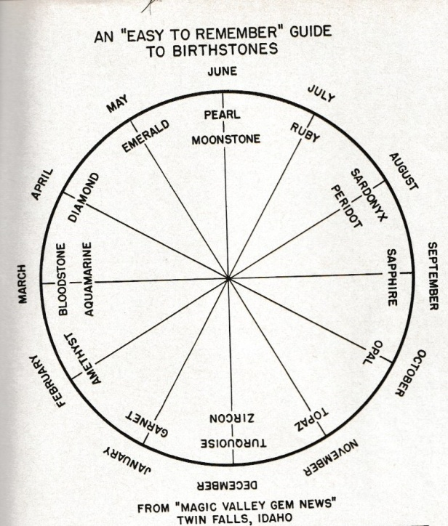

FEBRUARY

Amethyst

Amethyst, the February birthstone, comes in beautiful purple colors and makes a durable jewelry stone.
By Diana Jarrett GG RMV, Emily Frontiere

Amethyst, the modern and traditional February birthstone, has a rich history and strong symbolic ties to love and spirituality. Due to its beauty, availability, and durability, this purple gem has become a very popular jewelry stone. You'll find them in everything from simple stud earrings to delicate bracelets to bold statement rings.
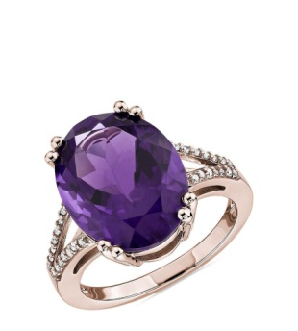

What Color is Amethyst?
Amethyst colors can range from pale lilac to deep reddish purple. A variety of quartz, amethyst gets its color from the presence of iron, other trace elements, and natural irradiation. (Don't worry, this occurs underground over millions of years and poses no health hazards).

How Do You Judge Amethyst Color?
Generally speaking, people want amethysts for their purple color. Therefore, the value of a particular stone depends almost entirely on how well it shows that color. The most prized amethyst stones feature a deeply saturated or "intense" purple color, perhaps with hints of violet or red hues. Stones with brown or bronze tinges usually have lower values. Amethyst may have light or dark tones. Most gem buyers favor darker tones. Look for a February birthstone that has its color distributed evenly throughout the stone, without noticeably paler or darker regions or striped patterns.

What are Siberian Amethysts?
Deep purple amethysts are valued the highest, and stones with this coveted hue as well as red and blue flashes are known as "Siberian Amethysts." These gems are typically considered the most valuable of their kind. Originally, the term referred to gems of this quality from Siberia, a source now depleted. Today, the term applies to any amethyst that shows this color, regardless of the source. "Siberian quality" represents the highest grade for amethyst color. After "Siberian," most amethysts receive grades from AAA to A. Darker stones receive AAA grades. Lighter stones receive A grades. (Keep in mind that these grades, while helpful when shopping, are not standardized. Amethyst grades and grading criteria may vary from jeweler to jeweler).

What are "Rose de France" Amethysts?
Pale, pinkish violet or lilac amethysts also have their appeal and aficionados. This color is referred to as "Rose de France." These gems can bring a light, romantic touch to your jewelry piece.
Even though most people prefer amethysts with a deep purple color (and prices reflect that), ultimately, you can choose the color that's ideal for you. After all, it's your jewelry. You should enjoy what you wear.

What are Ametrines?
On rare occasions, a quartz crystal forms that combines amethyst with citrine, the yellow/red-orange variety of quartz. The result is known as an ametrine. This gem features prominent purple and yellow or red-orange zones. Faceters cut these bi-colored gems to showcase these colors.
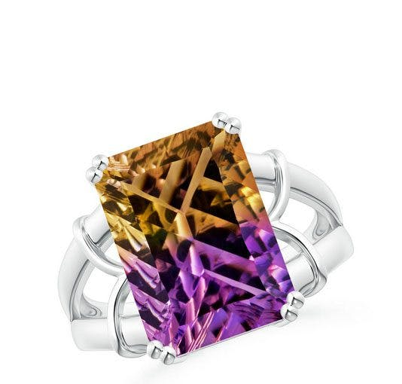

The History of the February Birthstone
People have used amethyst for jewelry and decorative objects for thousands of years. The Ancient Egyptians associated amethysts with the god Osiris and carved amethysts into animal-shaped amulets. In the Old Testament book of Exodus, amethyst is one of the stones in the breastplate of Aaron. The gemstone also appears as one of the foundation stones of the Heavenly City in the New Testament book of Revelation. Both these lists of Biblical gemstones contributed to the development of the modern idea of birthstones. During the Middle Ages, royalty proudly wore amethysts because the color purple was associated with nobility. High-ranking priests also wore amethysts to represent piety. Amethysts were considered to be one of the "cardinal gems," along with diamond, sapphire, ruby, and emerald. They were often used in crowns, scepters, and other royal regalia. At this time, only people of the highest social status wore amethysts. Over the centuries, more sources of the colorful gem were discovered, making it more available and affordable. Today, the February birthstone is one of the top choices for jewelry stones.

Amethyst Meaning and Folklore
Amethyst is not only the traditional and modern February birthstone but also the commemorative gem for sixth and seventeenth wedding anniversaries. Indeed, amethyst has strong connections to the month of February and love. According to legend, St. Valentine — whose day devoted to love we celebrate in February — wore an amethyst ring carved with Cupid's likeness. However, amethyst's most well-known symbolic association involves the prevention of drunkenness. In fact, the name "amethyst" itself comes from the Greek word amethystos, which means "not drunk." The Ancient Greeks believed you could drink all night and remain sober if you had an amethyst in your mouth or on your person. Sometimes they even added powdered amethysts to their drink to keep them from becoming inebriated. Perhaps as an extension of amethyst's supposed power to prevent intoxication, some people believe wearing this gem enhances fortitude and helps promote serenity, clear thoughts, and quick wit. In Yogic beliefs, amethyst is associated with the powerful Crown Chakra, located at the top of the head.

Where Does Amethyst Come From?
Amethysts are found in geodes, which are round rock formations that contain hollow cavities lined with crystals. Currently, many countries have productive deposits of amethyst. However, before the discovery of new deposits in Brazil in the 19th century, this gemstone was rare. Prior to that discovery, Russia was the leader in the global production of amethyst. More recently, Bolivia, Uruguay, and Zambia have produced gem-quality amethysts. Other notable producers include Canada, India, Mexico, Sri Lanka, and the United States. With so many sources, the February birthstone has now become widely available.

How to Buy Amethyst Jewelry
Aside from stunning purple colors, amethysts have other properties that make them excellent jewelry stones.

Availability, Affordability, and Quality
Beautiful and abundant, amethyst can grace any type of jewelry, from mass produced pieces to the finest custom couture creations. Since amethyst crystals can grow to massive sizes, gem faceters can also cut them precisely into calibrated sizes for jewelry settings or carve them into fantastic and distinctive pieces of art. Moreover, the availability of amethyst in large sizes means its price per carat goes up just gradually as the gems increase in size. This makes the February birthstone perfect for a jewelry statement piece. You can surely find an amethyst jewelry design that fits your style (and budget) perfectly.

Amethysts can be large enough to cut into unusual shapes. Since amethysts are so abundant, always choose stones with good transparency and clarity. Amethysts often contain inclusions, materials and cavities trapped within the crystal. However, you should have no trouble choosing eye-clean amethysts. That means you won't see the inclusions with the naked eye and they won't affect the stone's appearance.
You should also have no trouble finding a well-cut amethyst. Don't settle for a substandard cut. A poor cut will lower the stone's beauty and value, even if it has excellent color. Amethysts can receive brilliant cuts that enhance their brightness or other styles of cuts that emphasize deep color. Expert gem cutters will choose faceting designs that best showcase individual stones.

Matching Stones
There's another advantage to having large quantities of stones available. Jewelers can easily assemble matching sets of amethysts for earrings, necklaces, and bracelets. When shopping for any design with multiple amethysts, look for pieces with stones with matching color, size, and cut. Of course, if you want amethysts in graduated sizes or with different colors and cuts, look for that instead. Greater availability also makes assembling sets with harmonious variations easier.

Amethyst Durability
Amethysts have a Mohs hardness score of 7. That means they will resist scratches from everyday wear and tear, particularly from household dust. Although popular (and pricier) gemstones like diamonds, rubies, sapphires, and emeralds may surpass them in hardness, amethysts still make durable gemstones suitable for any type of jewelry use, including rings. In fact, with no cleavage — internal planes where the molecular bonds in the crystal are weak — amethysts are more resistant to breaking than diamonds. Just store your amethyst jewelry so it doesn't scratch against those other gemstones and your amethysts should give you a lifetime of enjoyment. Since amethysts are heat sensitive and often contain inclusions, don't clean them in mechanical systems that use steam or ultrasound. This could damage them. Excessive heat can cause their colors to fade, and vibrations could make inclusions shatter. Instead, use a soft brush, mild detergent, and warm water. See our gemstone jewelry care guide for more cleaning recommendations.

Where to Buy Amethyst Jewelry
You can find amethyst jewelry almost anywhere, from small brick-and-mortar shops to online retailers like James Allen, Blue Nile, Angara, and Custom Made. The finest material may be sold at auction or found in collections from the world's most luxurious jewelry brands.

WAMS Olympia is a proud member of:

